** *By Clear Industries***

A new way to seal ends of Spiral Duct and Fittings

* **These tough Spiral Duct Caps** provide secure protection in transfer, jobsite staging, installs and jobsite protection
* **From shipment to final Trim**, ducting is protected from dusts, debris and moisture
* **Labor saving** – caps install in seconds and are easily set to new location
* **Less monitoring required** during the construction process – films and shower caps are prone to damage resulting in additional material and labor costs
* **Reusable and recyclable** – re-use saves material and labor costs and helps reduce jobsite waste and debris
* **Helps meet** LEED jobsite requirements
* **Duct pipes** can now be stood on end to save space without damage to Yellow Caps
* **4” to 24”** diameters available

***Call for additional sizes, new and special applications Proudly made in the* USA**

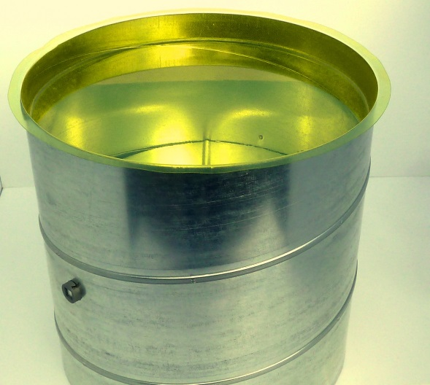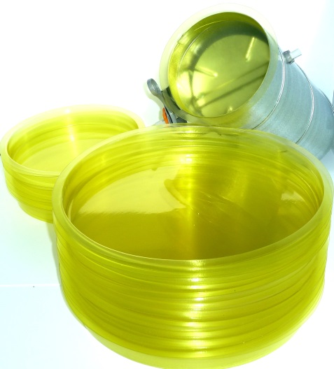[**rick@clearindustries.net**](mailto:rick@clearindustries.net) **360 598 1907 cell 206 777 5886**