

**Create your own trim packs**

Here is an example of how our covers can be used.

Here is what we do differently than our regular version of prefab device covers.

1. We drill 5/16” holes in covers above the device mounting screws
2. On these covers we drill all the mounting holes where trim plate holes would be.
3. NOTE – On the regular Pre-fab covers we only drill enough holes to hold covers firmly onto device, thus eliminating extra screws and labor (this is where our multi gang covers save time)
4. Once these units are assembled – we call them “Trim Packs”
5. We can prepare any cover like this 1-6 gang. Either switches, Standard Duplex or GFCI/Decora
6. On retro fits or any situation that might work, these assemblies can be made up in the shop and Save Installation Time on the jobsite
7. Benefits, units can be assembled with or without device ears and installed prior or after sheetrock

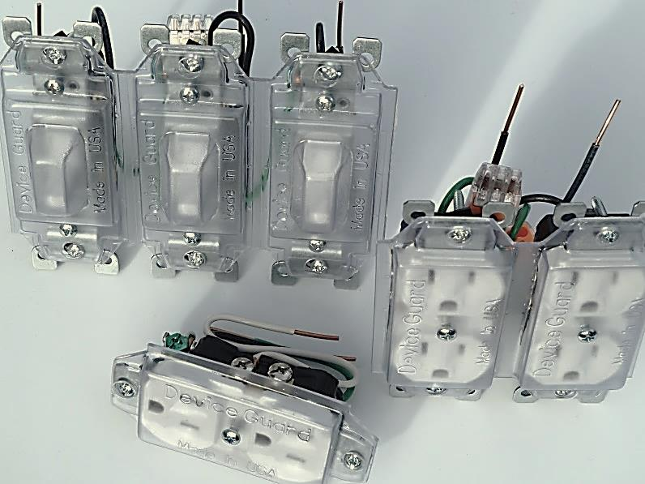

**ASSEMBLED UNITS – READY FOR INSTALLATION INTO MUDRING – SCREW TRIM PACKS ONTO MUDRING – ETHER LEAVE COVER IN PLACE FOR JOBSITE PROTECTION OR REMOVE COVER AND INSTALL TRIM PLATE – COVERS HOLD DEVICE ON PRECISE CENTERS, SO TRIM PLATE INSTALLATION IS MUCH QUICKER AND EASIER.**