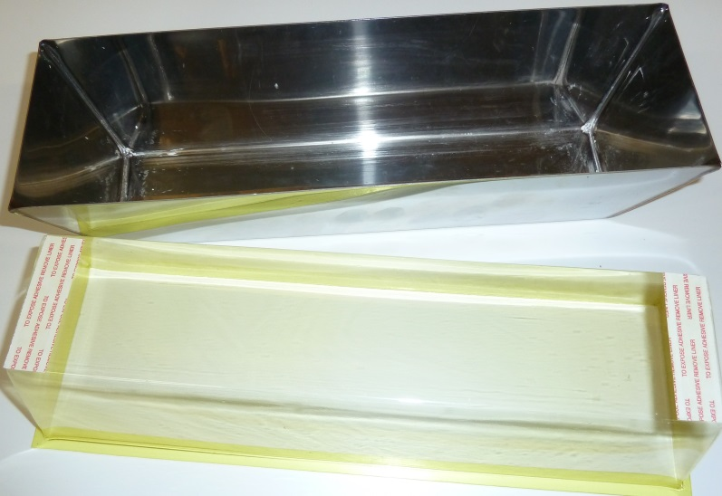 PAN LINER READY TO INSTALL – REMOVE TAPE LAYER AND PRESS INTO PAN
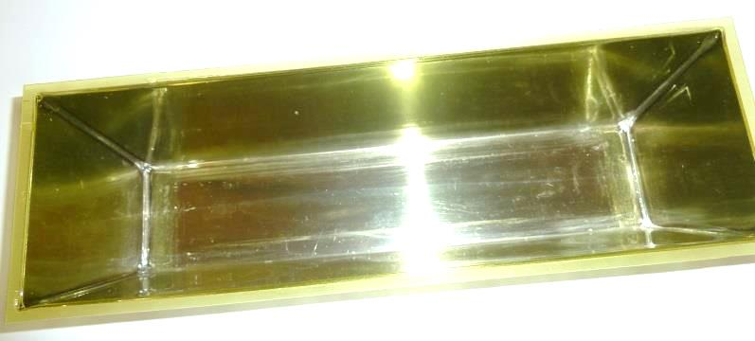 INSTALLED LINER
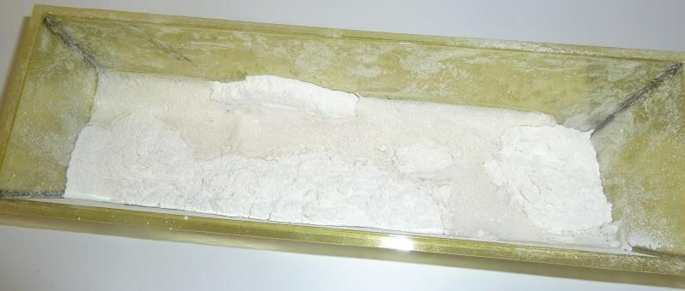 HOT MUD AND WATER
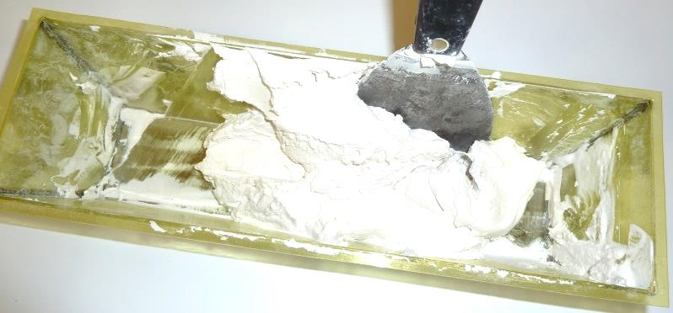 MUD MIXED AND READY
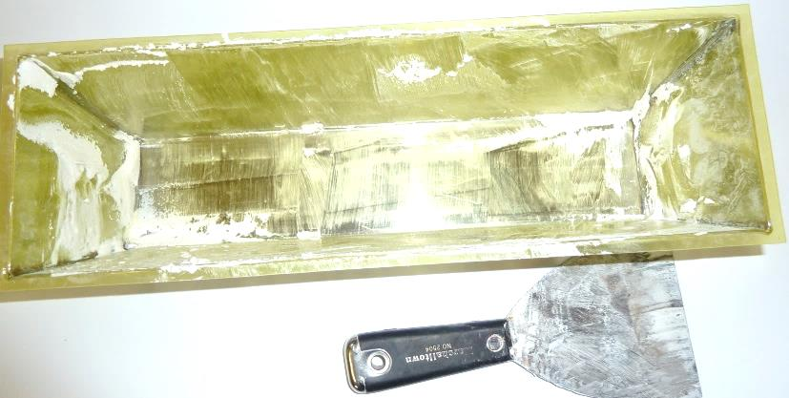 PAN CONTENTS EMPTY
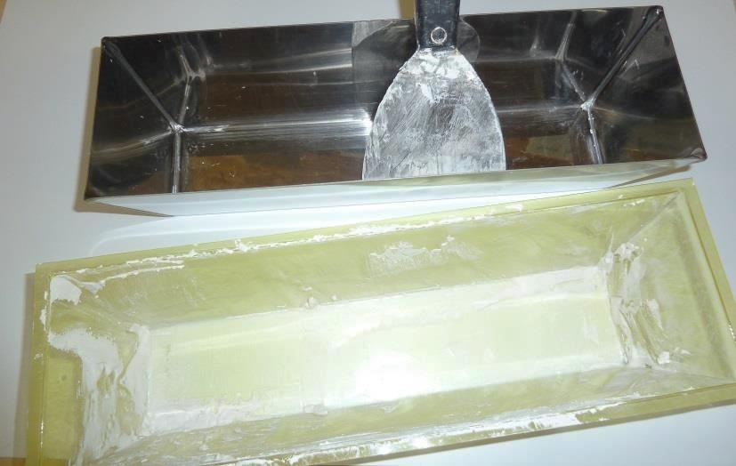 REMOVE LINER AND DISPOSE – PAN IS PERFECTLY CLEAN
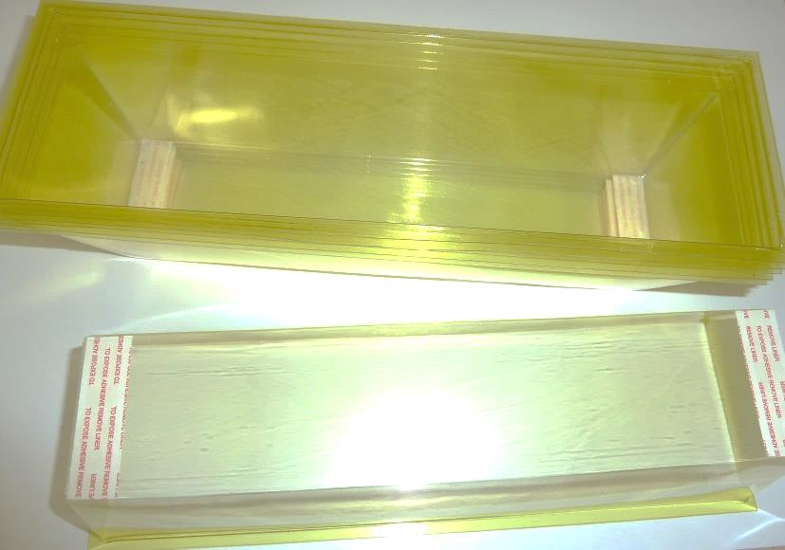 PICK UP SPEED LINERS FOR YOUR NEXT REPAIR OR ANYTIME YOU DON’T WANT TO CLEAN UP!
Working for the Electrical and Construction Industries – contact RICK@CLEARINDUSTRIES.NET

