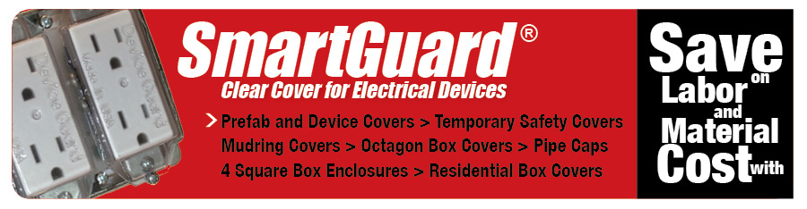
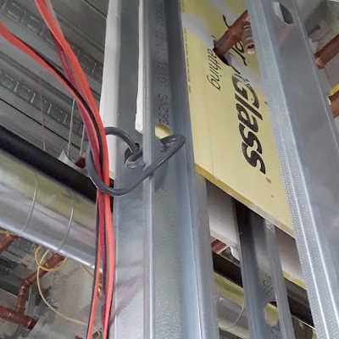
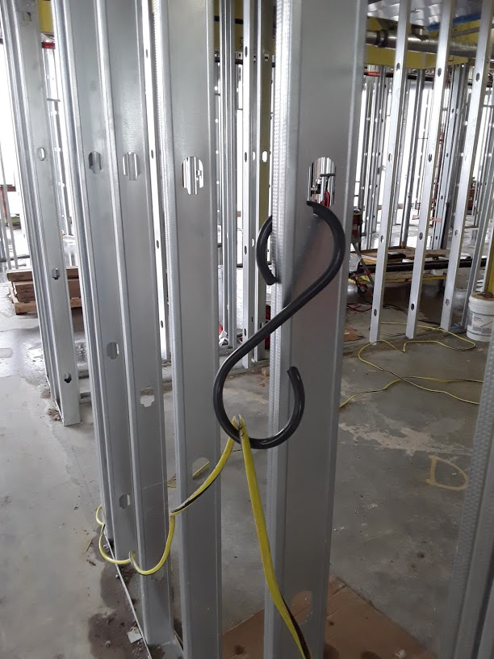
OUR “S” HOOKS IN ACTION!
SmartGuard’s EASY HOOKS are one of our newest offerings to meet the Electricians and General Contractors need for hanging temporary wiring, cords, cables and hoses. These are great for hanging temporary lighting, safety equipment, clothing and more. Our S hooks help to meet OSHA requirements for good housekeeping best practices.
These hooks have great memory and can be stretched open over 4″ pipes and snap right back into their original shape.
They are made from flame-rated, non-conductive, strong and durable PVC and meet UL 514C for non-conductive and flame-resistant characteristics! Also look at our 90-degree opposing loop hook for more versatility in your jobsite wire management systems.
Part No. SH11-Large 11” S-Hook
Part No. SH1190 – Large 11” S-Hook with 90°

For more information check out our website www.smartguardcovers.com
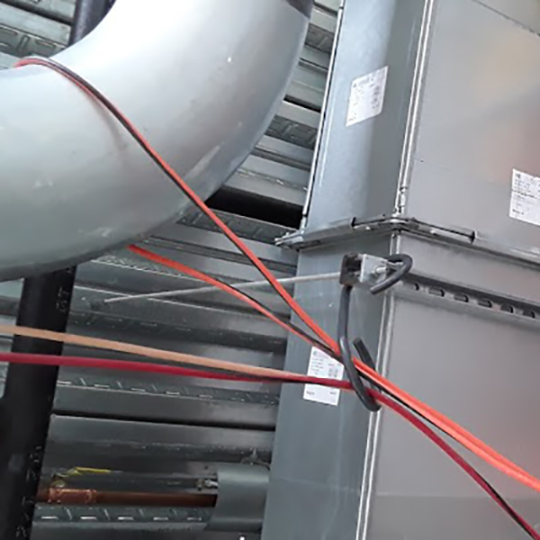

www.smartguardcovers.com rick@clearindustries.net
Office (360) 598-1907 Cell (206) 777-5886

