- SmartGuard TEMPORARY PANEL COVERS FOR BREAKER BOX, PANEL BOARDS AND DISTRIBUTION CENTERS
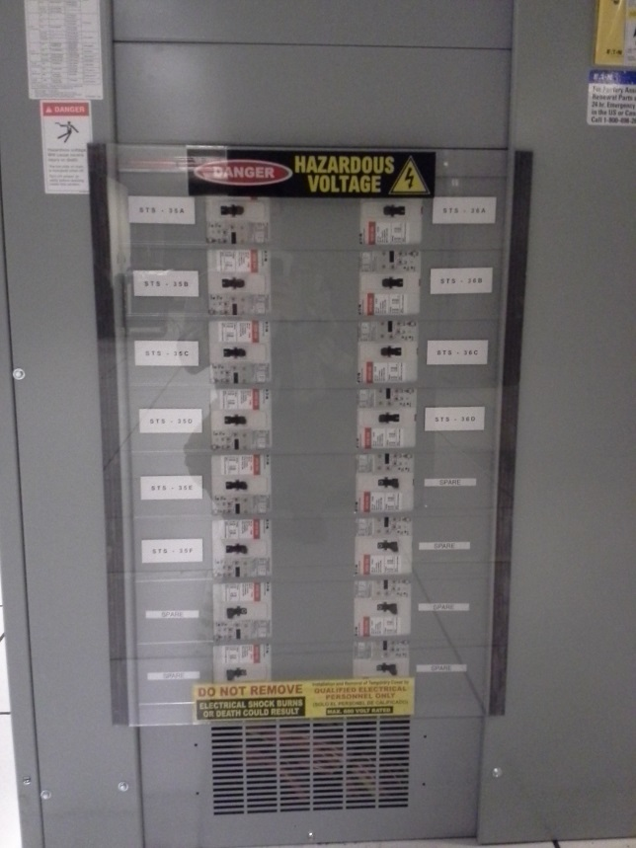 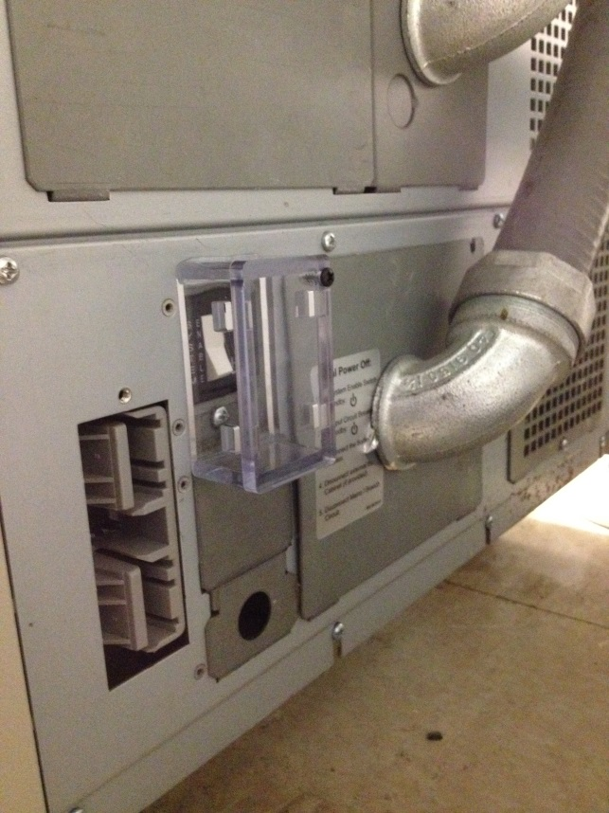 CRITICAL POWER BREAKER PANEL COVER CRITICAL SYSTEM BREAKER ENCLOSURE
For NOAA and Joint Base Andrews. We provided thick ultra clear PVC panel covers that had strong magnetic strips each side to hold covers firmly in place, these covers met UL Standard 514C, for dielectric strength and flame rating. Included are the mandatory ANSI warning labeling for In Place and Temp Panel Covers, we also provided material certifications sheets along with their order.
For Critical power USA and their customer Verizon we provided enclosures to add a layer of protection over their critical system breakers. This was made with .25” clear acrylic, polished sides and all edges glued.
Work with us to design and provide the Protection Covers you need for your Critical Power Requirements
We can provide covers and enclosures that are OSHA compliant in a wide variety of sizes and shapes
rick@clearindustries.net http://smartguardcovers.com phone 360 598 1907

