CUT SHEET DCP-1S and DCP-2S

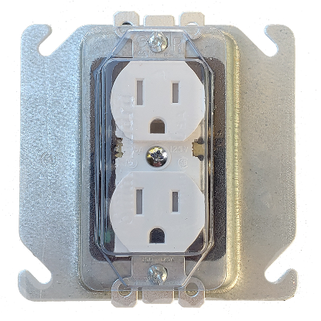
DCP-1S
SmartGuard 1 Gang duplex receptacle cover with mounting screw pre-installed
Part 1 Gang Device Cover
Dimension 2.19 x 4.1 x .33
Application Screws into device
Installation Method - Installs with 1 screw over device
Removal Method Unscrew and remove
Mil/Thickness 60 mil
Item Weight .3 oz.
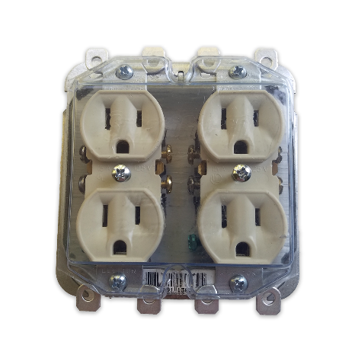
DCP-2S
SmartGuard 2 Gang duplex receptacle cover with mounting screws pre-installed
Part 2 Gang Device Cover
Dimension 3.7 x 4.18 x .33
Application Screws into device
Installation Method - Installs with 2 screws over device
Removal Method Unscrew and remove
Mil/Thickness 60 mil
Item Weight .5 oz.

UL 514C – SmartGuard Covers Meet Standards for Fire Rating and Dielectric Strength

